**Gender proportion**

Like the following pictures, for most states, the gender proportion changes dramatically and no rules to analyze or summarize. In addition, extreme values often occur in the graph, such as the ratio of male to female equals 1 to 0(maybe it is because that the origin dataset is not big enough).

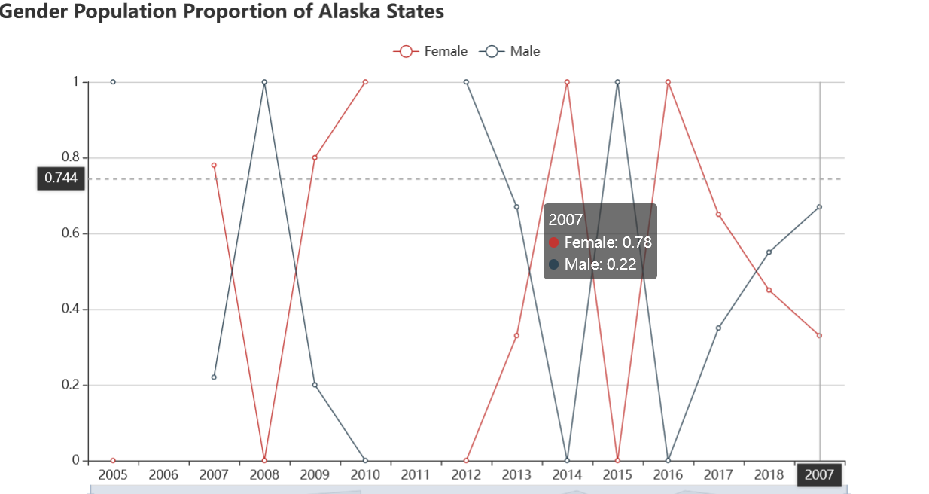

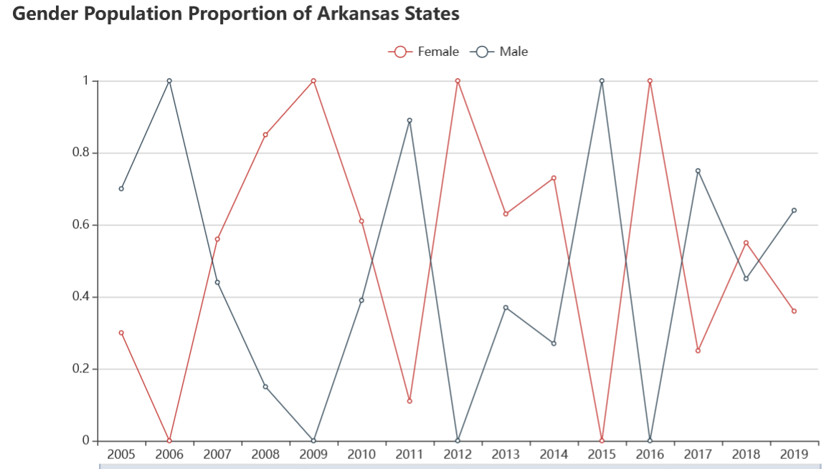

Due to this condition, We decided to forgo writing descriptions for each state's gender ratio. We believe our graphs can clearly show the unique changes in each state.